Assignment 2 Player’s Guide

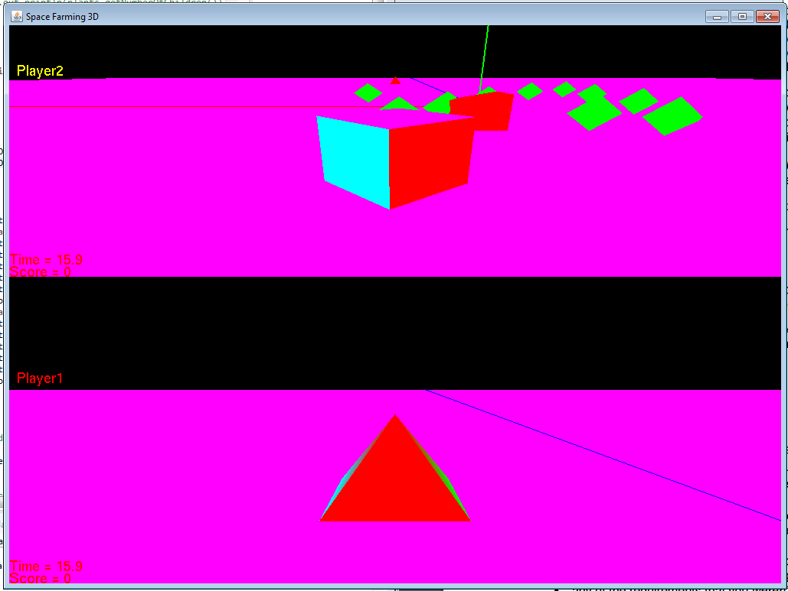

To run program, double-click the “Assignment 2 run” batch file.

To run in command prompt, navigate to where the zip file is located then type “javac MyGame.java”

Player 1 controls: Use the keyboard to control the Pyramid on the bottom screen.

* W: move forward
* S: move backward
* A: strafe left
* D: strafe Right
* Arrow keys: rotate/zoom camera

Z key alternates between camera modes for both players.

Player 2 controls: Use a game pad to control the Cube on the top screen.

* Left stick: move/strafe
* Right stick: rotate/zoom camera

In order to score points, players must run into the green plants. Once a plant is collected, it will stack on top of the red truck. Each plant can only be collected once. The plants start out in a different location each time the game starts.

I tested this program with an Xbox One controller on the “PAC-MAN” computer .

Features I wasn’t able to implement are collisions, and a second node controller.